# WT-SFP-E

Copper SFP Transceiver

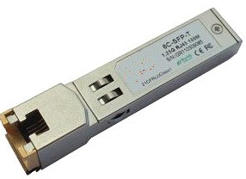

## Features

* Up to 1.25Gb/s bi-directional data links
* Hot-pluggable SFP footprint
* Extended case temperature range (0°C to +70°C )
* Fully metallic enclosure for low EMI
* Low power dissipation (1.05 W typical)
* Compact RJ-45 connector assembly
* Access to physical layer IC via 2-wire serial bus
* 1000 BASE-T operation in host systems with SERDES interface
* 10/100/1000Mbps compliant in host systems with SGMII interface

## Applications

* 1.25 Gigabit Ethernet over Cat 5 cable

## Description

* AT-SFP-T Copper Small Form Pluggable (SFP)transceivers is high performance, cost effective module compliant with the Gigabit Ethernet and 1000- BASE-T standards as specified in IEEE 802. 3-2002 and IEEE 802.3ab, which supp- orting 1000Mbps data- rate up to 100 meters reach over unshielded twisted-pair category 5 cable. The module supports1000 Mbps full duplex data-links with 5- level Pulse Amplitude Modulation (PAM) signals. All four pairs in the cable are used with symbol rate at 250Mbps on each pair. The module provides standard serial ID information compliant with SFP MSA, which can be accessed with address of A0h via the 2wire serial CMOS EEPROM protocol.
* The physical IC can also be accessed via 2wire serial bus at address A0h.

